LoRaWAN TEMPERATURE AND HUMIDITY SENSOR NODE
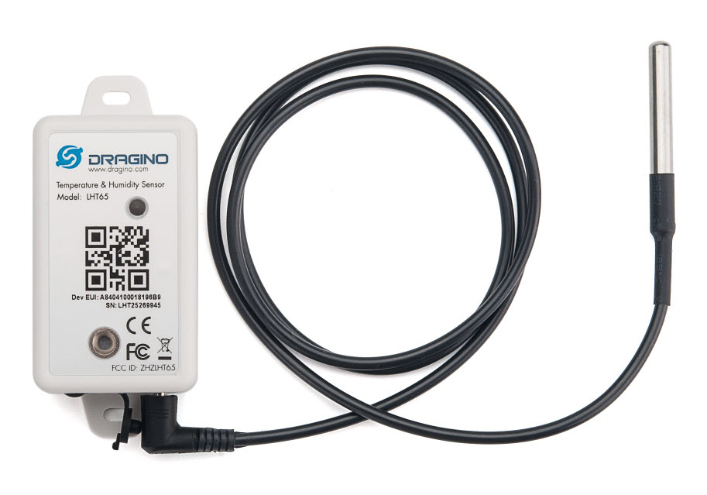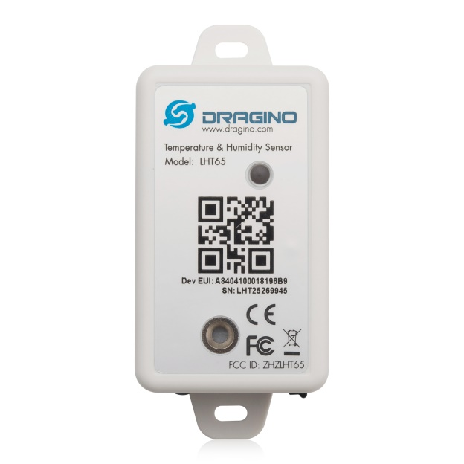
Description
The Dragino LHT65 Temperature & Humidity sensor is a Long Range LoRaWAN Sensor. It includes a built-in SHT20 Temperature & Humidity sensor and has an external sensor connector to connect to external sensors such as Temperature Sensor, Soil Moisture Sensor, Tilting Sensor etc .

The LHT65 allows users to send data and reach extremely long ranges. It provides ultra-long range spread spectrum communication and high interference immunity whilst minimizing current consumption. It targets professional wireless sensor network applications such as irrigation systems, smart metering, smart cities, building automation, and so on.

LHT65 has a built-in 2400mAh non-chargeable battery which can be used for more than 10 years*.

LHT65 is full compatible with LoRaWAN v1.0.2 protocol, it can work with standard LoRaWAN gateway.

LHT65 has 3200 data records with date time which can be retrieved with date time for further analyze.
Features
- LoRaWAN Class A protocol
- Frequency Bands: 865-867 MHz
- AT Commands to change parameters
- Remote configure parameters via LoRaWAN Downlink
- Firmware upgradable via program port
- Built-in 2400mAh battery for more than 10 year use.
- Built-in Temperature & Humidity sensor
- Optional External Sensors
- Tri-color LED to indicate status
- 3200 set sensor record with time stamp

Specification
Built-in Temperature Sensor
- Resolution: 0.01 °C
- Accuracy Tolerance : Typ ±0.3°C
- Long Term Drift: < 0.02 °C/yr
- Operating Range: -40 ~ 125°C

Built-in Humidity Sensor
- Resolution: 0.04%RH
- Accuracy Tolerance : Typ ±3%RH
- Long Term Drift: < 0.02°C/yr
- Operating Range: 0 ~ 100°C
External Temperature Sensor
- Resolution: 0.0625°C
- ±0.5°C accuracy from -10°C to +85°C
- ±2°C accuracy from -55°C to +125°C
- Operating Range: -55°C ~ 125°C

Power Consumption
- LHT65 (without external sensor): Idle: 3uA. Transmit: max 130mA.
- LHT65 + E1 Sensor: Idle: 4uA, Transmit: max 130mA.
Storage & Operation Temperature: -40°C to +85°C

